
Maraton
Genomics Distribution Computing System
October 22, 2015
YHGenomics

Contents
1. Third-part Library 3
1.1. Libuv 3
1.1.1. Description 3
1.1.2. Usage 3
1.1.3. API 3
1.2. Json 4
2. UML Diagram 5
2.1. Class Relation 5
2.2. Data Flow Diagram 5
2.2.1. Connection Flow 5
2.2.2. Session Close Flow 6
2.2.3. Cluster Session Data Flow 6
2.2.4. HTTP Session Data Flow 6
3. Interface Layout 7
3.1. Singleton<T> 7
3.1.1. static instance() 7
3.2. Manager<T> 7
3.2.1. void push(T* instance) 7
3.2.2. bool pop(T* instance) 7
4. Protocol Layout 8
5. Utility 9
5.1. CircleBuffer 9
5.1.1. push(const char* data, int len) 9
5.1.2. char* pop(int len) 9
5.2. Buffer 9
5.2.1. Buffer(const Buffer& buffer) 9
5.2.2. Buffer(const Buffer&& buffer) 9
5.2.3. Buffer& operator=(Buffer& buffer) 9
5.2.4. Buffer& operator=(Buffer&& buffer) 9
5.2.5. raw(const char* data,int len) 10
5.2.6. char* raw() 10
5.2.7. int length() 10
5.3. Logger 10
5.3.1. static void sys(const char* fmt,…) 10
5.3.2. static void error(const char* fmd,…) 10
5.4. Zlib 10
5.4.1. Buffer compress(const char* data,int len) 10
5.4.2. Buffer uncompress(const char* data , int len) 11
5.5. UUID 11
5.5.1. static string create() 11
6. Network Layout 12
6.1. Network Socket 12
6.1.1. UVSockService 12
6.1.2. SessionManager<TT> 12
6.1.3. Session 13
6.1.4. HTTPSession 14
6.1.5. ClusterSession 14
6.1.6. ExecutorSession 15
6.1.7. MasterSession 15
6.2. HTTP Protocol Layout 16
6.2.1. HTTPHandler 16
6.2.2. HTTPRouter 16
6.2.3. HTTPRequest 17
6.2.4. HTTPResponse 18
7. Master Layout 20
7.1. Master Session 20
8. Executor Layout 21
8.1. Utility 21
8.1.1. Resource Descriptor 21
8.1.2. Appraiser 23
8.2. Message Handler Layout 25
8.3. Task Processing Layout 25
8.3.1. Task Receiving 25
8.3.2. Environment Checking 25
8.3.3. Pre-load Data Checking 25
8.3.4. Local Computing 25
8.3.5. Local Result Cache 25
8.3.6. Reliable Report Delivery 25
8.3.7. Exception Processing 25

Third-part Library

Libuv
http://libuv.org/

Description
libuv is a multi-platform support library with a focus on asynchronous I/O

Usage

API

uv_tcp_init(uv_loop_t* loop,uv_tcp_t* tcp)
Initial a TCP socket

uv_ip4_addr(char* ip,sockaddr_in* sockaddr)
Initial a ipv4 address

uv_tcp_bind(uv_tcp_t* handle,const sockaddr* sock,uint flag)
Bind an address to a sock

uv_tcp_connect(uv_connect_t* conn,uv_tcp_t* tcp,sockaddr* sockaddr,uv_connect_cb cb)
Connect to a remote TCP server

Json
Checkout http://nlohmann.github.io/json/

UML Diagram

Class Relation
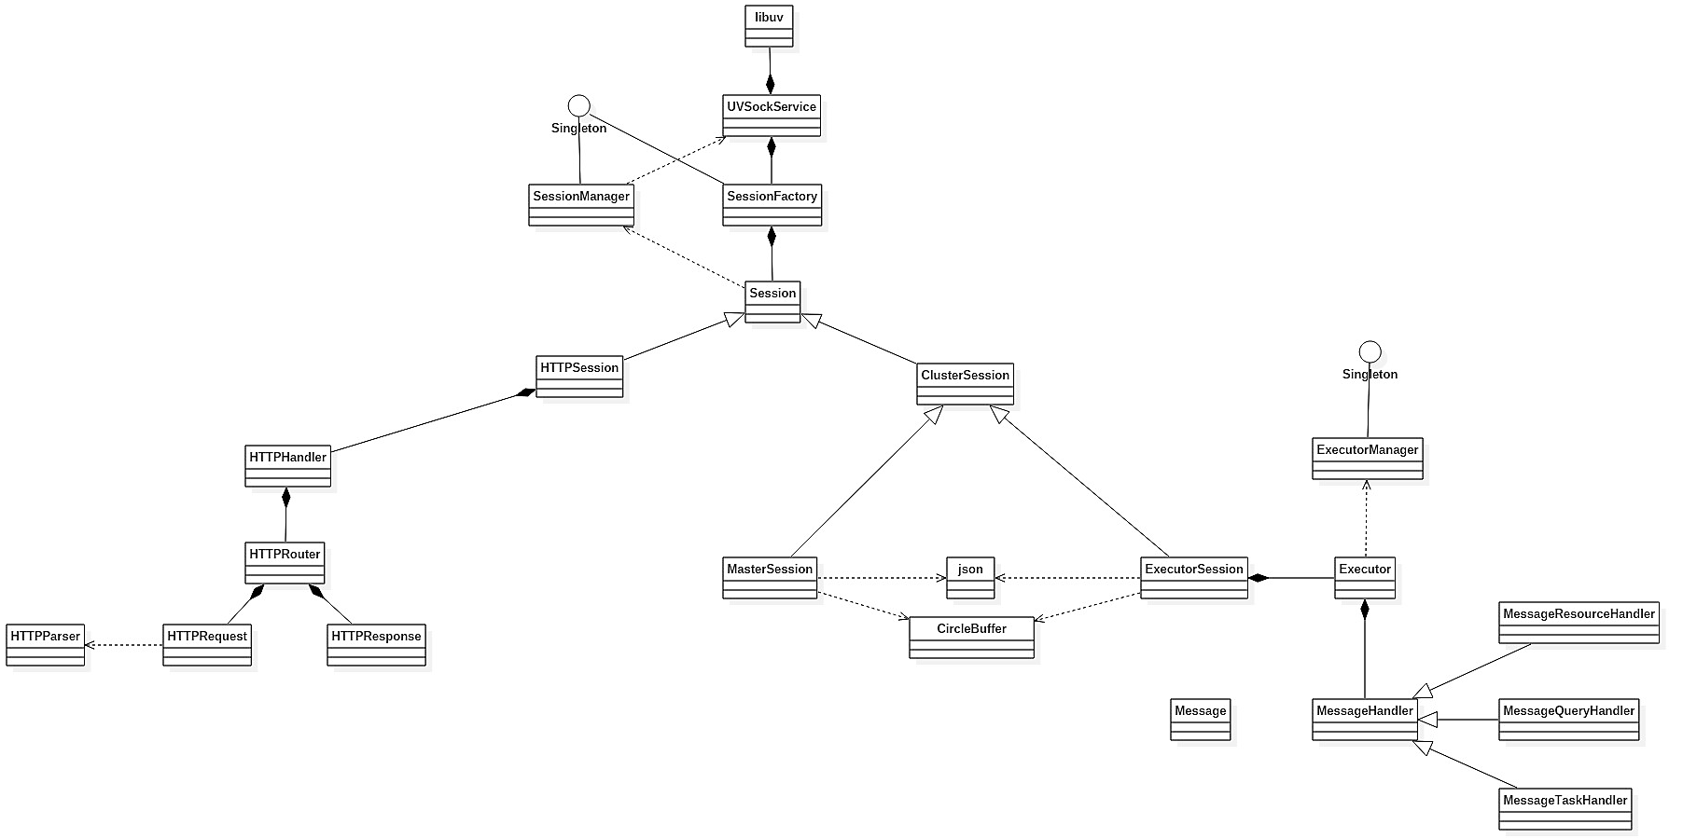

Data Flow Diagram

Connection Flow
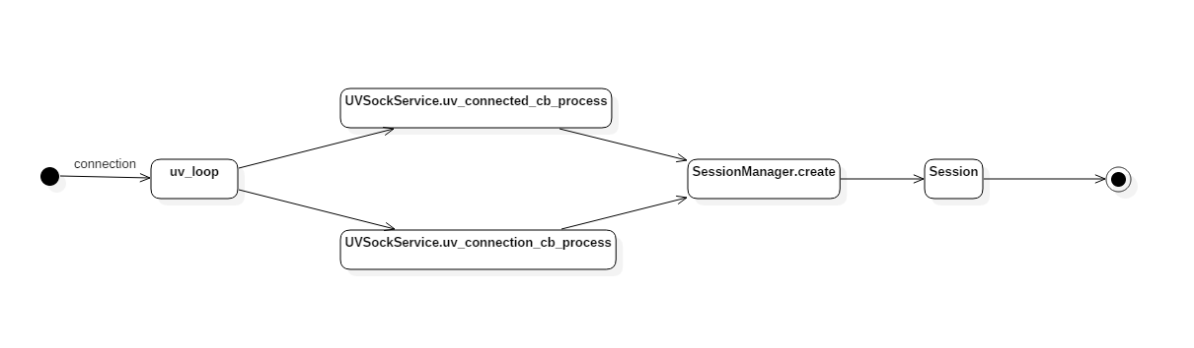

Session Close Flow
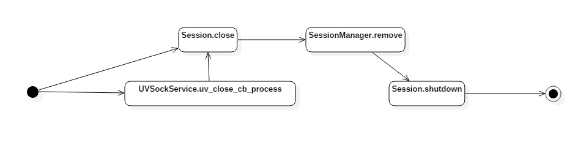

Cluster Session Data Flow
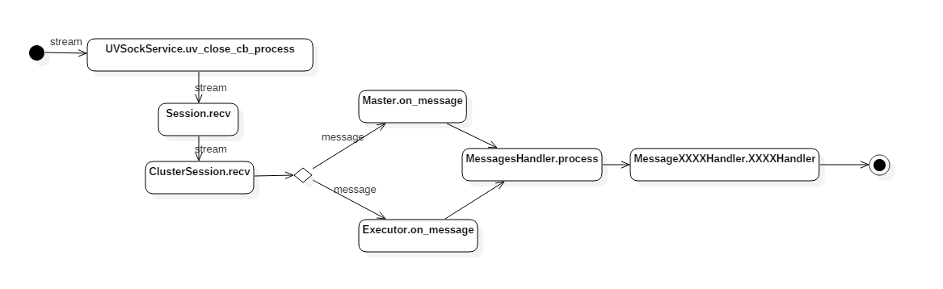

HTTP Session Data Flow
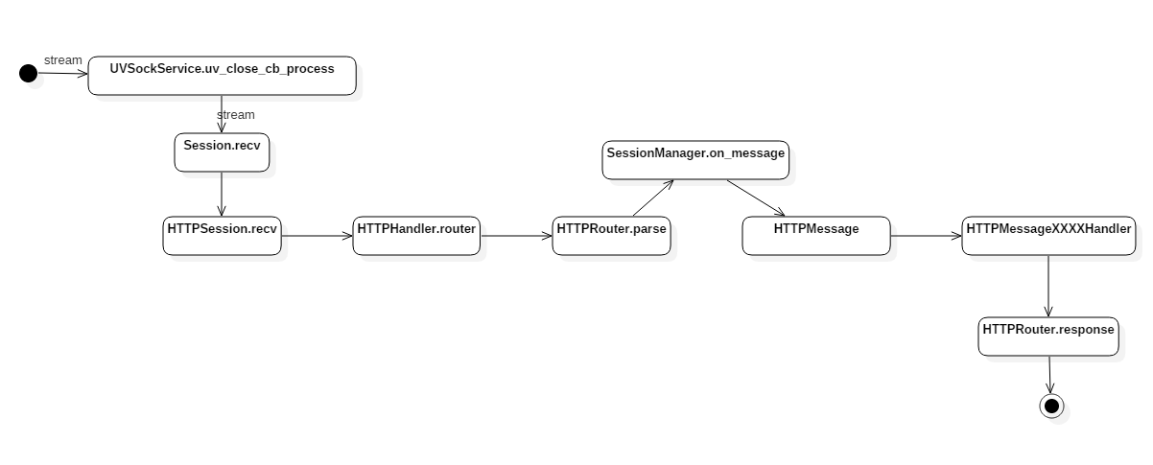

Interface Layout

Singleton<T>
Template class for making a singleton class.
Children classes must declare friend Singleton<T> in your private region.

static instance()
Return the instance of class

Manager<T>
Provide manager function

void push(T* instance)
Add a new element to the set

bool pop(T* instance)
Remove na element in the set
PS: This function will not free the memory

Protocol Layout

Utility

CircleBuffer
Provide a circle-buffer for saving memory.

push(const char* data, int len)
Add a data to the buffer

char* pop(int len)
Remove and return the data with len length

Buffer
Provide a memory data struct with data pointer and data length

Buffer(const Buffer& buffer)
Copy construction

Buffer(const Buffer&& buffer)
Move construction

Buffer& operator=(Buffer& buffer)
Override operator

Buffer& operator=(Buffer&& buffer)
Override operator

raw(const char* data,int len)
Setter.
Set Buffer data and length
This function will copy the data and not release the input data.

char* raw()
Getter.
Return the pointer of the data

int length()
Getter
Return the data length

Logger
Provide a logger function

static void sys(const char* fmt,…)
Output the string in sys-format

static void error(const char* fmd,…)
Output the string in error-format

Zlib
Provide a crypt, decrypt, compress and decompress functions

Buffer compress(const char* data,int len)
Compress the data.
This functions will copy data into Buffer and not release the input data

Buffer uncompress(const char* data , int len)
Compress the data.
This functions will copy data into Buffer and not release the input data

UUID
Make a UUID

static string create()
Return a UUID string

Network Layout

Network Socket
Core network classes. Control all the function that network communication needs. Including manage session, creating memory for receiving data, handling HTTP requests, dispatching message.

UVSockService
Main network class. Provide the basic function of network. Includes Receiving data, Connecting to server, Accepting client, Releasing Session.

bool listen( std::string ip, int port );
Make socket in server mode, that will accept income connection
This method must invoke in first place before run()

bool connect( std::string ip, int port );
Make socket in client mode, that will connect to the target server
This method must invoke in first place before run()

void run();
Run the main loop
This function will block the thread, any logic, register must be set before
The last function to start a network service

SessionManager<TT>
Session manager, will manage all the session, splits sessions by class type (TT)
Provide functions to add, remove, find, callback

Parent Class
- Manager<T>
- Singleton<SessionManager<T>>

Custom Type
- std::function<void( TT* )> callback_t

TT* create(uv_tcp_t*)
Create a session for type TT by passing uv_tcp_t to it

bool remove(TT* t)
Remove the target session

TT* find( TT* t)
Find the target session by it instance.
If there is not such session it will return nullptr, otherwise return the instance.

void on_create(callback cb)
Callback when a new session was created by manager

void on_close(callback cb)
Callback when a session was closed by manager

Session
Basic session class provide a way to use it.
It provides sending, closing function to control the network communication.

void close()
Close the session
This function will not effact immediately until next loop.

void send(const char* data,int len)
Send the data to socket
This function will not effact immediately until next loop.

HTTPSession
HTTP protocol session, created by port 80.
It provides way to control HTTP request, response the request, format data, verify data

Parent Class
- Session

HTTPHandler* handler();
Return the handler pointer.
Detail usages, jump to the HTTPHandler chapter

ClusterSession
Basic class for cluster node.
Parse the network stream.
Verify the data

Parent Class
- Session

virtual send(Message* message)
Send the message to the remote
This function will not copy the pointer, so DO NOT delete the point until finish send.

virtual on_message( callback )
Callback when a message is arrived.
It will notice children class that messages are arrived.

virtual on_close( callback )
Callback when the session was closed.
It will notice children class that current session was close by some reason.

ExecutorSession
Provide functions to communicate with the target executor. Including sending messages, closing connection.
This class is only used for master mode.

Parent Class
- ClusterSession

void send( Message* message)
Send a message to current executor.
This function send(const char*, int len) to send raw binary data.
The function will not copy the pointer of message, so DO NOT delete the pointer until function returns.

MasterSession
Provide functions to communicate with the master. Including sending messages, closing connection.
This class is only used for executor mode.

Parent Class
- ClusterSession

void send( Message* message)
Send a message to current master.
This function uses send(const char*, int len) to send raw binary data.
The function will not copy the pointer of message, so DO NOT delete the pointer until function returns.

HTTP Protocol Layout

HTTPHandler
Provide HTTP formatting function.
This class depends on HTTPRouter. It does nothing but forward router to front.

HTTPRouter
Provide usages for routing the http request, including mapping path to target handler, parsing HTTP raw text data, creating response for request.

void parse( const char* data, int len)
parse data and dispatch the request
If parsing fail the function will not dispatch the request until success.

response( callback )
Register a callback that determines how to send data to the client.
Callback when the class needs sending data to the client.

get(string path, callback)
Register a GET request on [path].
Callback when a GET request with the path arrived
Start with “/“

post(string path, callback)
Register a Post request on [path]
Callback when a POST request with the path arrived

HTTPRequest
Format the HTTP raw text data into HTTP request protocol. Including reading the HTTP header, splitting path, method and body.

string method()
Return the HTTP request method.
Currently supporting:
GET
POST

string path()
Return the HTTP request path.
By getting the path, you can assign different handler to it.
The root path is ‘/’

map<string,string> header()
Return the HTTP request header.

string body()
Return the HTTP body data.

bool parse( const char* data, size_t len )
Parse the input data to a correct HTTP request. In some cases, a HTTP request will break into several pieces, so the function will keep the older data until it can be a correct HTTP request.
In some cases, it must be invoke several times to parse one HTTP request.
It will NOT release the input pointer.

HTTPResponse
Provide functions to make response easier, including automatically adding header, filling Content-Length, adding Content-Type

void status(int status)
Set the response status
Currently support
200(OK)
404(Not Found)

int status()
Return the status
Currently support
200(OK)
404(Not Found)

void header(string name, string value)
Add a response header with name and value.
If header name is already existed, it will cover the old value

void content(string content)
Set the response content
This function will automatically compute the length, so DO NOT add Content-Length by yourself.

int length()
Return the length of response content
The length is automatically computed by the content that you input.

Buffer bytes()
Serialize the HTTP Response into HTTP raw text.

clear()
Reset the response. Cleanup all the data that has been input

Master Layout

Master Session

Executor Layout

Utility
There are plenty of supports need for Executor doing its work, such as gathering the information of the processing node, handling of the messages in and out, and so on.

Resource Descriptor
Resource Descriptor returns the measurements of the executor’s resources.
For the basic resource type which can be measure by simple factor, such as the available physical memory size, that direct values will be returned.
In a more complicated case, when a higher level abstract measurement, such as the processing ability of the executor, is needed, a black-box test returning a score is used. Such test will be high level and equally for different kinds of executor so that the return value can be comparable, for example, a processing time for same pre-load date from stage A to stage B.
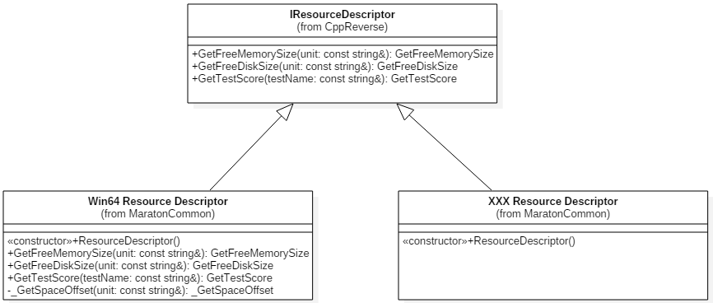

Basic Interface
As the description of resources changes platform to platform, in respect to the open-close principle, each platform should use their own descriptor.
So a basic interface should be designed, and a non-implement flag should be return by default.
Here, the basic interface is designed as the IResourceDescriptor with three virtual methods.
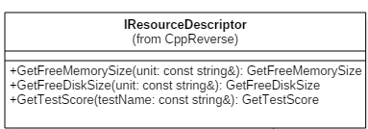

Free Memory Size
This method is defined as
virtual size_t GetFreeMemorySize( const string& unit )
By default, this method returns -1 as a non-implement flag.
Each implement should at least with the ability to return the size of the available physical memory in MB.
Each implement should use the white-list strategy to handle the string unit, and return -1 for any unexpected value.

Free Disk Size
This method is defined as
virtual size_t GetFreeDiskSize( const string& unit )
By default, this method returns -1 as a non-implement flag.
Each implement of this method should return the size of the free disk space size in MB.
Each implement should use the white-list strategy to handle the string unit, and return -1 for any unexpected value.

Test Score
This method is defined as
virtual size_t GetTestScore( const string& testName )
By default, this method returns -1 as a non-implement flag.
Each implement should pass a test name and let the appraiser factory can run the corresponding appraiser and return the value of the test.

The WIN64 Resource Descriptor
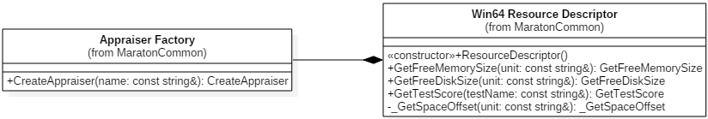
As the window APIs may not useful for the OS version in future, neither forward nor backward compatibility is supported.
GlobalMemoryStatusEx is used for getting the available physical memory. The dwLength member in the MEMORYSTATUSEX must be set before calling the GlobalMemoryStatusEx method, or the result could be over unbelievable.
GetDiskFreeSpaceEx is used for getting the free disk space size.
And for the getting of the test score, an Appraiser was used as it be told later.

The linux(64bit) Resource Descriptor

Appraiser
Technically the measurement of the processing ability of a certain processing node is hard to describe by a little numbers of low level factors, so a high level black-box test is a better idea.
Each appraiser implement a certain interface define as IAppraiser with a virtual method( size_t GetScore() ) to run the test and give back the score( -1 by default as a non-implement flag).
A plenty of Appraisers can be created by their names with a factory, and more appropriate appraiser can be designed and add to the factory later.
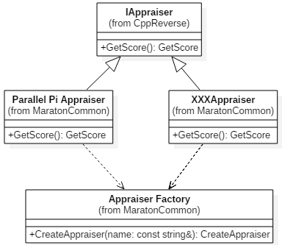

Appraiser Factory
Simple factory can fulfill this task very well for now. And when the time of an Appraiser Boom coming, the configure files or reflection may be a choice.
The create method return a unique_ptr of the IAppraiser. The raw(or naked) pointer is not recommended.
unique_ptr<IAppraiser> CreateAppraiser( const string& name );

Appraisers List
A header file does the very simple management job for the plenty of appraisers. Consider it as the poor man’s configure file and mostly for getting a little tidier code in the factory implement file.

Parallel Pi Appraiser
Appraise by a Parallel computing version of Pi calculation. Use OpenMP for the parallel processing which can make full use of available resources of the processing node.

Simulated100MB Appraiser

Message Handler Layout

Task Processing Layout

Task Receiving

Environment Checking

Pre-load Data Checking

Local Computing

Basic computing

Quality of Data

Faults and Fault-tolerant

Local Result Cache

Reliable Report Delivery

Exception Processing

